Student Name / Ahmed Mahmoud Elsayed Abdel Mawla

B.N / 18

Github link /

Github pages /

Date / 4/6/2020

Topic Brief :
Big data is the term for a collection of data sets so large and complex that it becomes difficult to process using on-hand database management tools or traditional data processing applications.

Why is Big Data Important ?
The importance of big data does not revolve around how much data a company has but how a company utilises the collected data. Every company uses data in its own way; the more efficiently a company uses its data, the more potential it has to grow. The company can take data from any source and analyse it to find answers which will enable:
- Cost Savings : Some tools of Big Data like Hadoop and Cloud-Based Analytics can bring cost advantages to business when large amounts of data are to be stored and these tools also help in identifying more efficient ways of doing business.
- Time Reductions :The high speed of tools like Hadoop and in-memory analytics can easily identify new sources of data which helps businesses analyzing data immediately and make quick decisions based on the learnings.
- Understand the market conditions : By analyzing big data you can get a better understanding of current market conditions. For example, by analyzing customers’ purchasing behaviors, a company can find out the products that are sold the most and produce products according to this trend. By this, it can get ahead of its competitors.
- Control online reputation: Big data tools can do sentiment analysis. Therefore, you can get feedback about who is saying what about your company. If you want to monitor and improve the online presence of your business, then, big data tools can help in all this.
- Using Big Data Analytics to Boost Customer Acquisition and Retention
The customer is the most important asset any business depends on. There is no single business that can claim success without first having to establish a solid customer base. However, even with a customer base, a business cannot afford to disregard the high competition it faces. If a business is slow to learn what customers are looking for, then it is very easy to begin offering poor quality products. In the end, loss of clientele will result, and this creates an adverse overall effect on business success. The use of big data allows businesses to observe various customer related patterns and trends. Observing customer behaviour is important to trigger loyalty.
- Using Big Data Analytics to Solve Advertisers Problem and Offer Marketing Insights
Big data analytics can help change all business operations. This includes the ability to match customer expectation, changing company’s product line and of course ensuring that the marketing campaigns are powerful.
- Big Data Analytics As a Driver of Innovations and Product Development
Another huge advantage of big data is the ability to help companies innovate and redevelop their products.

Applications of Big Data in Real Life:-
1. Big Data in Education Industry:
Education industry is flooding with huge amounts of data related to students, faculty, courses, results, and what not. Now, we have realized that proper study and analysis of this data can provide insights which can be used to improve the operational effectiveness and working of educational institutes.
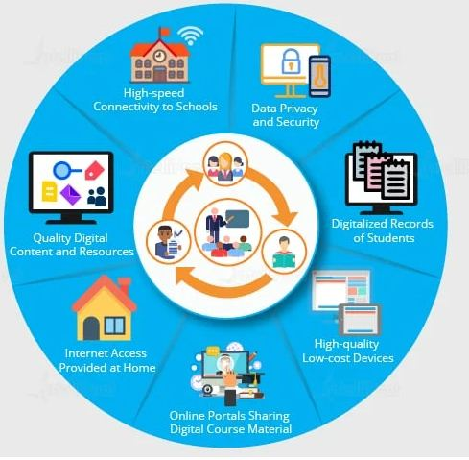

2. Big Data in Healthcare Industry:
Healthcare is yet another industry which is bound to generate a huge amount of data. Following are some of the ways in which big data has contributed to healthcare:
- Big data reduces costs of treatment since there is less chances of having to perform unnecessary diagnosis.
- It helps avoid preventable diseases by detecting them in early stages. It prevents them from getting any worse which in turn makes their treatment easy and effective.
- Patients can be provided with evidence-based medicine which is identified and prescribed after doing research on past medical results.
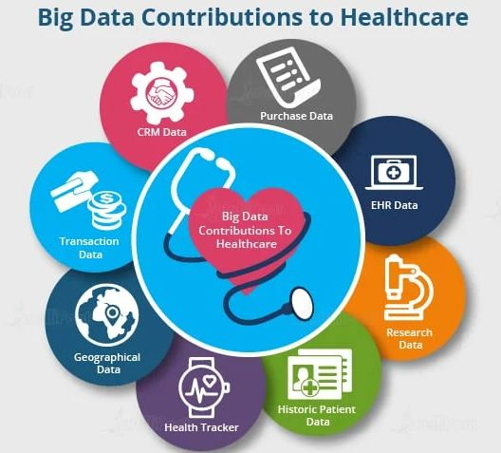

3. Big Data in Government Sector:
Governments, be it of any country, come face to face with a very huge amount of data on almost daily basis. The reason for this is, they have to keep track of various records and databases regarding their citizens, their growth, energy resources, geographical surveys, and many more. All this data contributes to big data. The proper study and analysis of this data, hence, helps governments in endless ways. Few of them are as follows:
Welfare Schemes
- In making faster and informed decisions regarding various political programs
- To identify areas that are in immediate need of attention
- To stay up to date in the field of agriculture by keeping track of all existing land and livestock.
- To overcome national challenges such as unemployment, terrorism, energy resources exploration, and much more.
Cyber Security
- Big Data is hugely used for deceit recognition.
- It is also used in catching tax evaders.
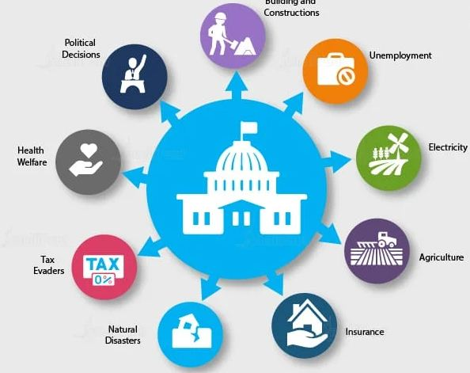

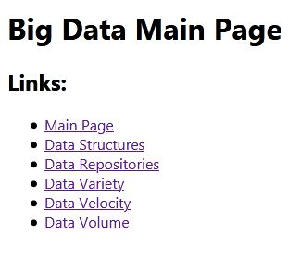
Screenshots:-
1.
2.
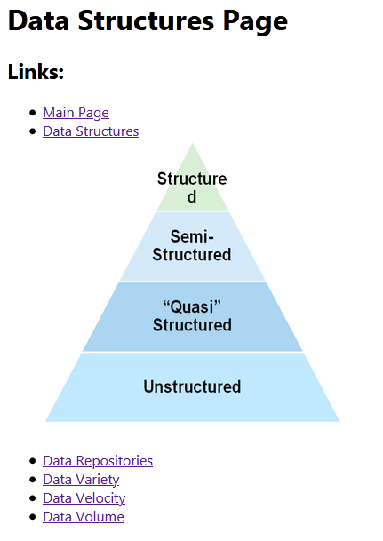

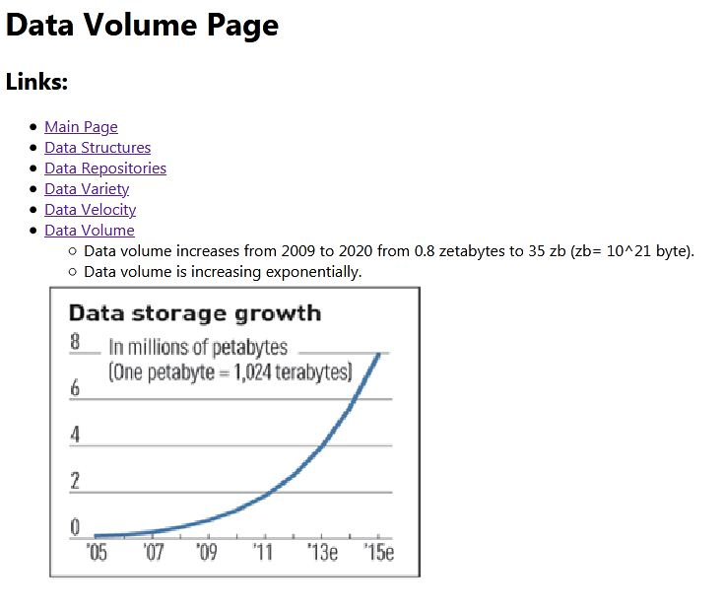
3.

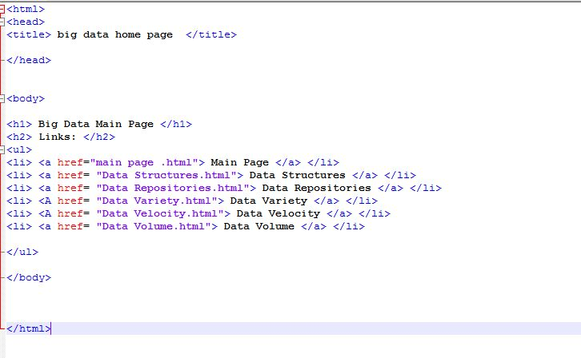
Source Code:
